Day 9
1. Fix the bugs in below snippet.
Given Code:
<html lang="en">
<head>
<title>Document
<body>
guvi
</title>
</head>
<div>
Lorem ipsum dolor sit amet consectetur adipisicing elit.
<div>
<div>
Guvi Geek Network
</div>
</body>
</html>

Rectified Code:
<html lang="en">
<head>
<title>Document guvi</title>
</head>
<body>
<div>Lorem ipsum dolor sit amet consectetur adipisicing elit.</div>
<div>Guvi Geek Network</div>
</body>
</html>

Output:
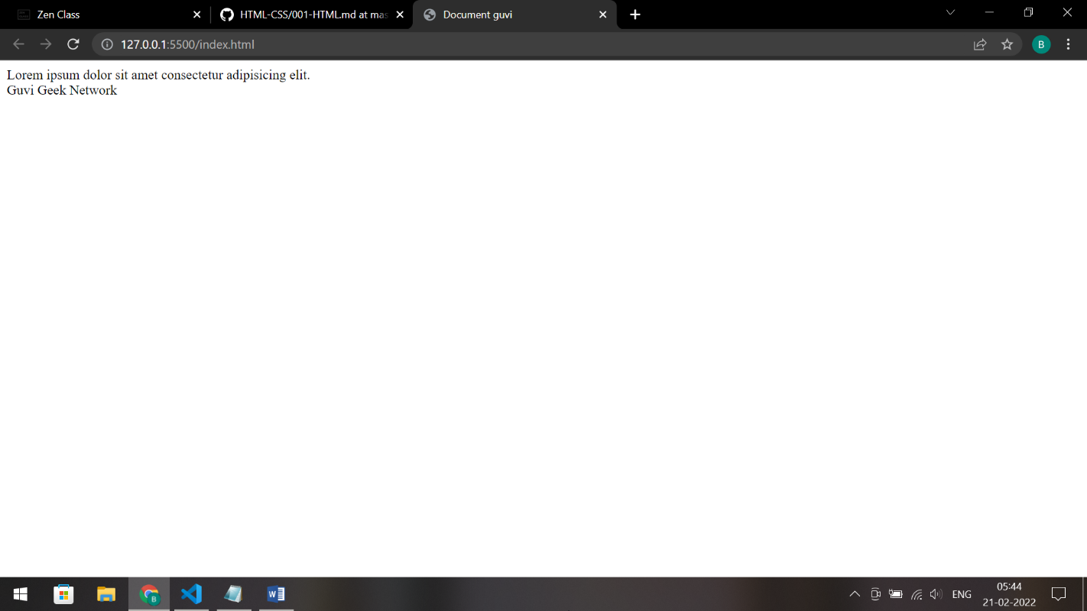

2. Try the below one.
Given Code:
<html lang="en">
<head>
<title>Document
<body>
guvi
</head>
<div>
Lorem ipsum dolor sit amet consectetur adipisicing elit.
<div>
<div>
Guvi Geek Network
</div>
</body>
</html>

Answer: This HTML code does not function properly as the tags are misplaced in the document.

3. Design a contact us form with all fields as required.
Code:
<!DOCTYPE html>
<html lang="en">
<head>
<meta charset="UTF-8" />
<meta http-equiv="X-UA-Compatible" content="IE=edge" />
<meta name="viewport" content="width=device-width, initial-scale=1.0" />
<title>Contact Us</title>
</head>
<body>
<div>
<form>
<label>NAME<sup style="color: red">*</sup> : </label>
<input type="text" placeholder="Your Name" required />
<br /><br />
<label>EMAIL<sup style="color: red">*</sup> : </label>
<input type="email" placeholder="Your Email" required />
<br /><br />
<label>MESSAGE<sup style="color: red">*</sup> : </label>
<input type="text" placeholder="Your Message" required />
<br /><br />
<label>ADDITIONAL DETAILS : </label>
<input type="text" placeholder="Additional Details" />
<br /><br />
<button type="reset">RESET</button>
<button type="submit">SUBMIT</button>
</form>
</div>
</body>
</html>

Output:
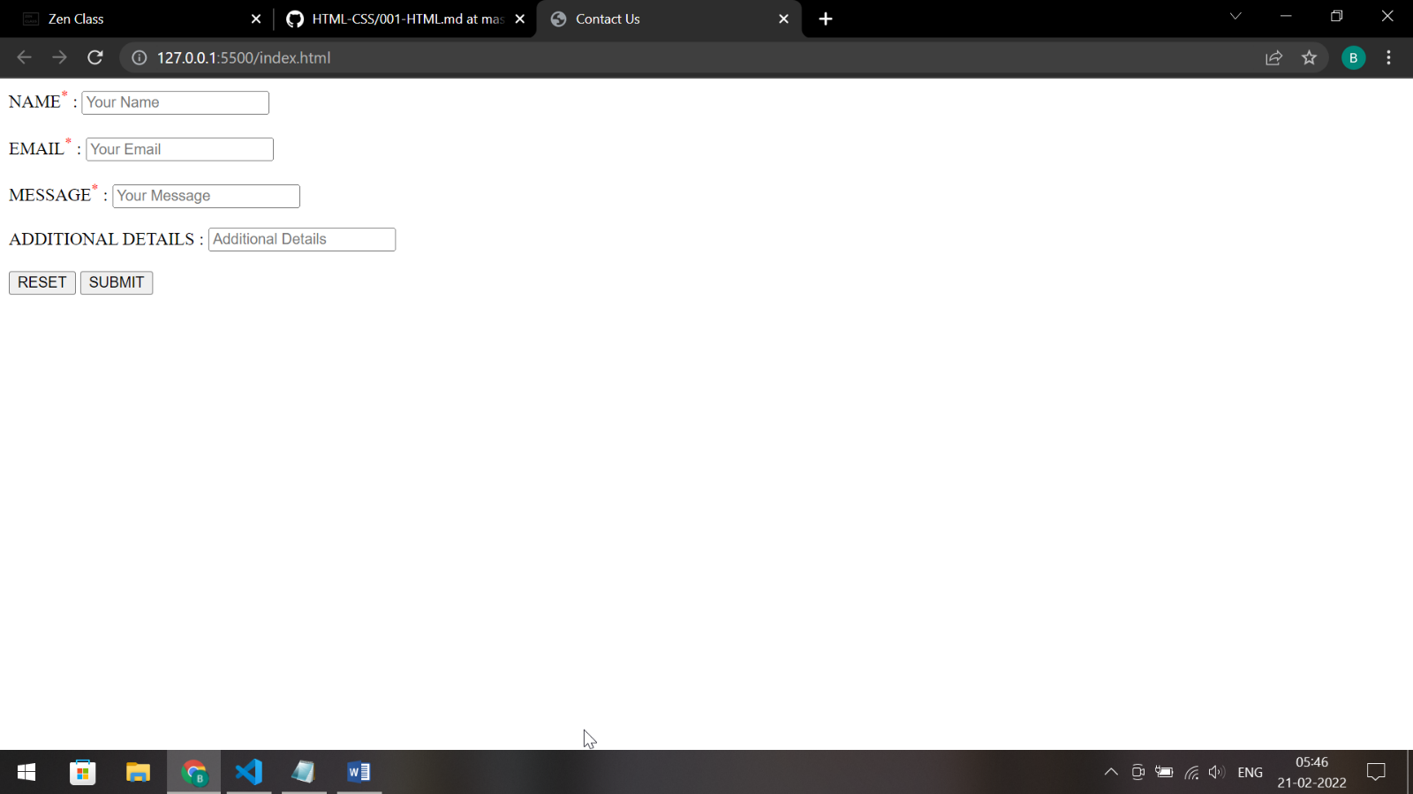

4. Use certain HTML elements to display the following in a HTML page.
Code:
<!DOCTYPE html>
<html lang="en">
<head>
<meta charset="UTF-8" />
<meta http-equiv="X-UA-Compatible" content="IE=edge" />
<meta name="viewport" content="width=device-width, initial-scale=1.0" />
<title>Document</title>
</head>
<body>
<div>
<ul>
<li>Programming Language
<ul>
<li>
Javascript
<ol type="a">
<li>Angular</li>
<li>React</li>
<li>Vue.js</li>
</ol>
</li>

<li>
Python
<ol type="a">
<li>Django Framework</li>
<li>Flask Framework</li>
</ol>
</li>

<li>
Java
<ol type="a">
<li>Spring</li>
<li>Maven</li>
<li>Hibernate</li>
</ol>
</li>
</ul>

<li>Database
<ul>
<li>MySQL</li>
<li>MongoDB</li>
<li>Cansandra</li>
</ul>
</li>
</ul>
</ul>
</div>
</body>
</html>

Output:
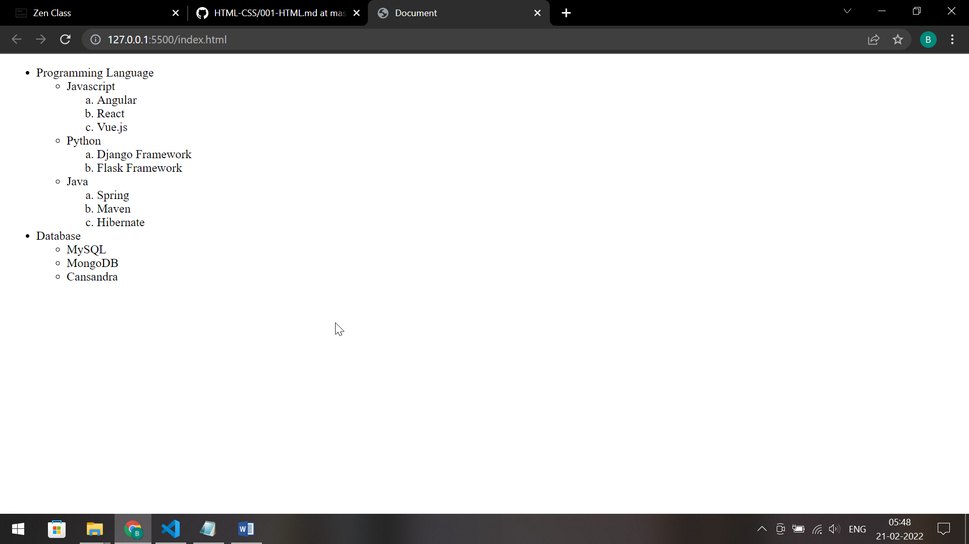

5. Create an element that helps you to open the https://google.com in separate new tab.
Code:
<!DOCTYPE html>
<html lang="en">
<head>
<meta charset="UTF-8" />
<meta http-equiv="X-UA-Compatible" content="IE=edge" />
<meta name="viewport" content="width=device-width, initial-scale=1.0" />
<title>Document</title>
</head>
<body>
<div>
<a href="https://google.com" target="_blank">Google</a>
</div>
</body>
</html>

Output:
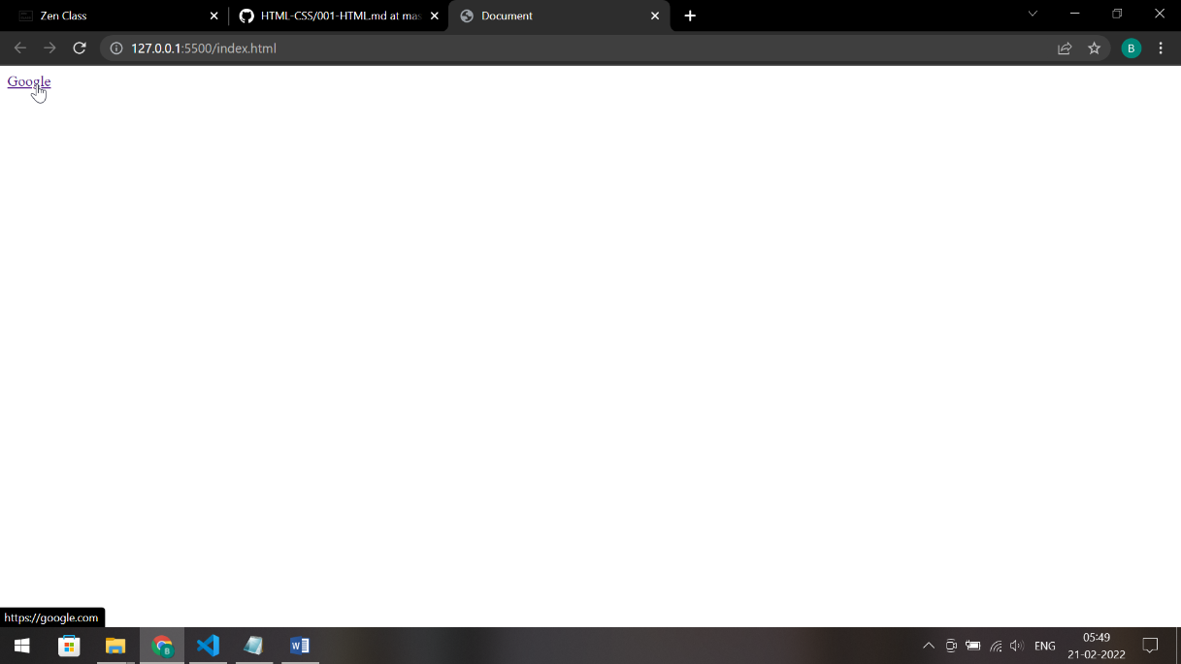
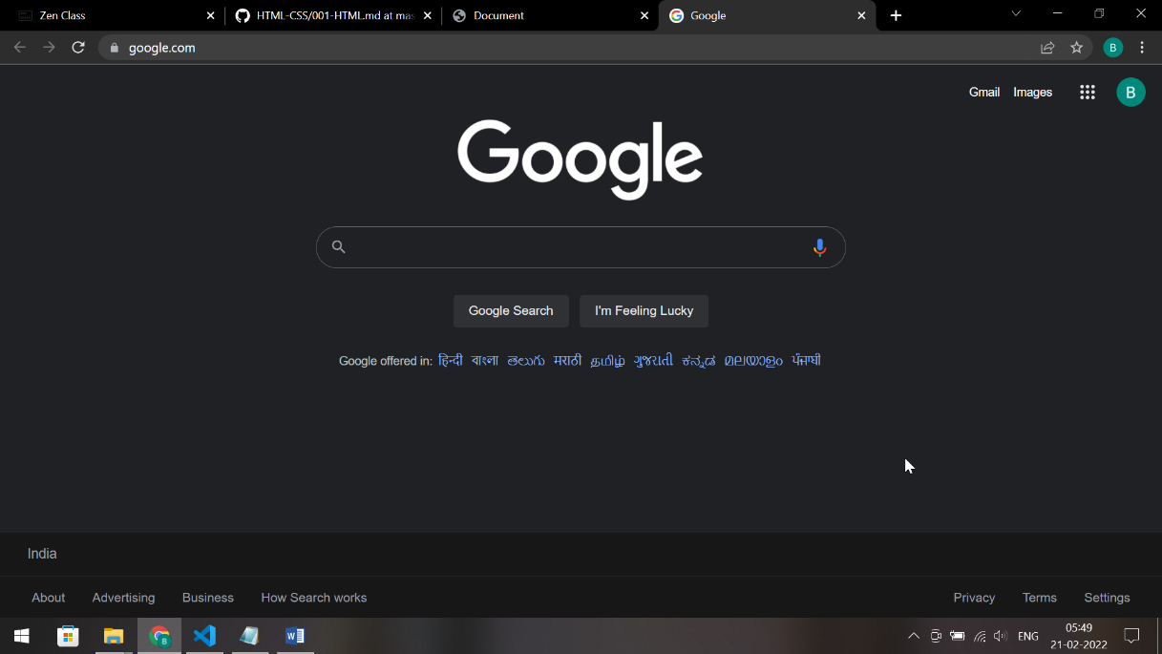

6. In the form, add two radio buttons with grouping them for employee type(Salaried and own business)
Code:
<!DOCTYPE html>
<html lang="en">
<head>
<meta charset="UTF-8" />
<meta http-equiv="X-UA-Compatible" content="IE=edge" />
<meta name="viewport" content="width=device-width, initial-scale=1.0" />
<title>Document</title>
</head>
<body>
<div>
<form>
<label>NAME : </label>
<input type="text" placeholder="Your Name" required /><br /><br />
<label>EMAIL : </label>
<input type="email" placeholder="Your Email" required /><br /><br />
<label>SEX : </label>
<input type="radio" />Male <input type="radio" />Female<br /><br />
<label>EMPLOYEE TYPE : </label>
<input type="radio" />Salaried <input type="radio" />Own Business<br /><br />
<button type="reset">RESET</button>
<button type="submit">SUBMIT</button>
</form>
</div>
</body>
</html>

Output:
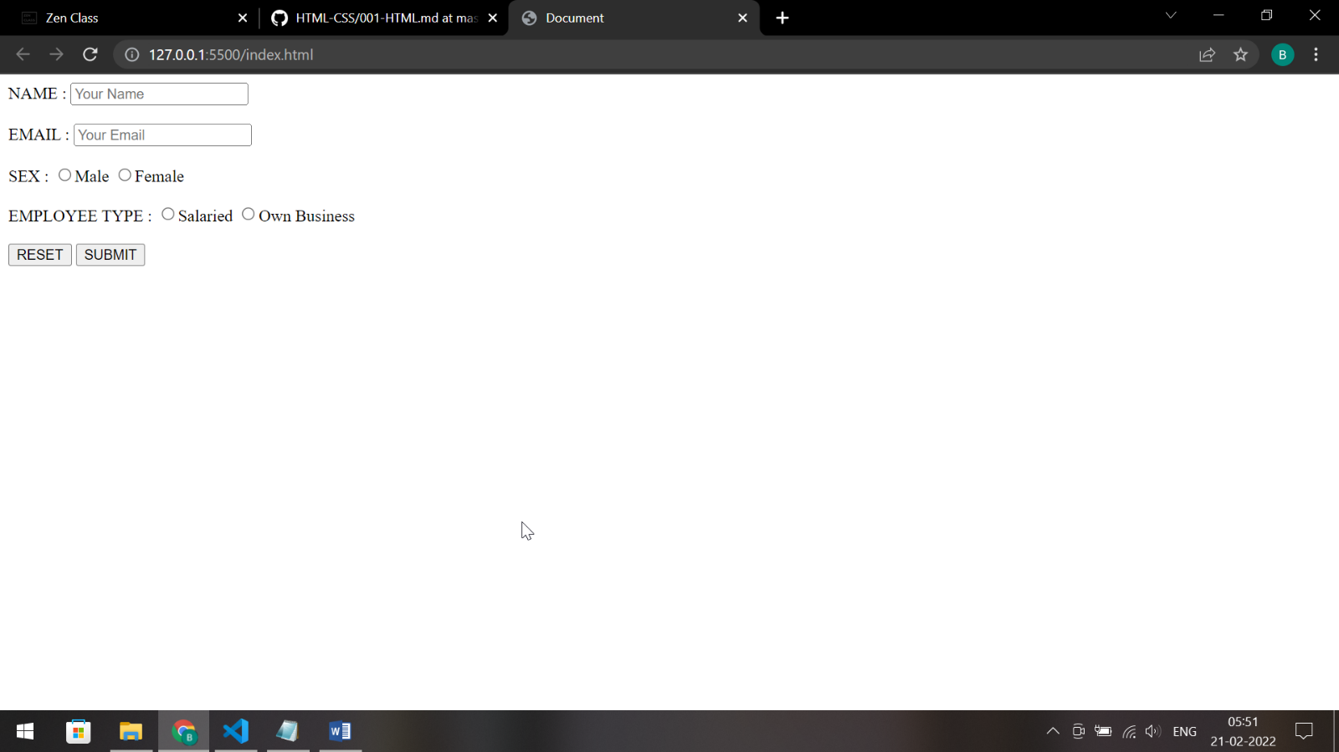

7. Design form shown in the link (http://evc-cit.info/cit040/formguide/card_0.png)
Code:
<!DOCTYPE html>
<html lang="en">
<head>
<meta charset="UTF-8" />
<meta http-equiv="X-UA-Compatible" content="IE=edge" />
<meta name="viewport" content="width=device-width, initial-scale=1.0" />
<title>Document</title>
</head>
<body>
<div>
<form>
<h2 style="color: red">
Yes! I want to subscribe to <em>Mag-O-Zine</em>
</h2>
<label>First Name</label><br />
<input type="text" placeholder="" required /><br /><br />
<label>Last Name</label><br />
<input type="text" placeholder="" required /><br /><br />
<label>Address</label><br />
<input type="text" placeholder="" required /><br /><br />
<label>City</label><br />
<input type="text" placeholder="" required /><br /><br />
<label>State</label><br />
<input type="text" placeholder="" required /><br /><br />
<label>Subscribe for: </label>
<input type="checkbox" />1 year ($19.95) <input type="checkbox" />2
years ($35.00)<br /><br />
<label>Send me more information about:</label><br />
<input type="checkbox" />Computer_Zine<br />
<input type="checkbox" />Fishing_Zine<br />
<input type="checkbox" />Cat_O_Zine
</form>
</div>
</body>
</html>

Output:
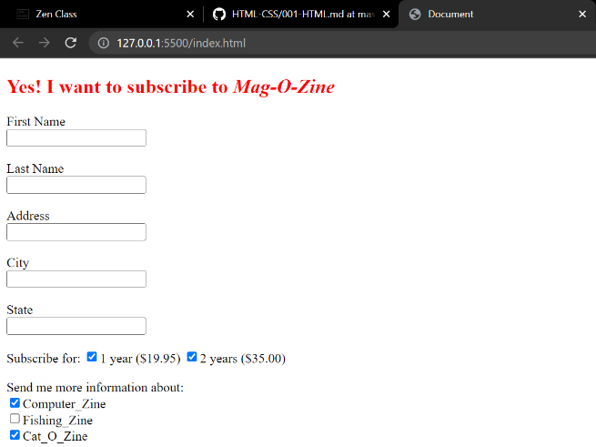
8. Use the table tag to design given image.
Code:
<!DOCTYPE html>
<html lang="en">
<head>
<meta charset="UTF-8" />
<meta http-equiv="X-UA-Compatible" content="IE=edge" />
<meta name="viewport" content="width=device-width, initial-scale=1.0" />
<title>Document</title>
<style>
h2 {
text-align: center;
}
table {
border-style: none;
width: 50%;
text-align: center;
}
td,
th,
tr {
border: 0.5px solid black;
}
.center {
margin-left: auto;
margin-right: auto;
}
</style>
</head>
<body>
<div>
<h2>Health Chart</h2>
<table cellspacing="0" cellpadding="10" class="center">
<tr>
<th rowspan="2">State of Health</th>
<th colspan="2">Fasting Value</th>
<th>After Eating</th>
</tr>
<tr>
<th>Minimum</th>
<th>Maximum</th>
<th>2 hours after eating</th>
</tr>
<tr>
<td>Healthy</td>
<td>70</td>
<td>100</td>
<td>Less than 140</td>
</tr>
<tr>
<td>Pre-Diabetes</td>
<td>101</td>
<td>126</td>
<td>140 to200</td>
</tr>
<tr>
<td>Diabetes</td>
<td>More than 126</td>
<td>N/A</td>
<td>More than 200</td>
</tr>
</table>
</div>
</body>
</html>

Output:
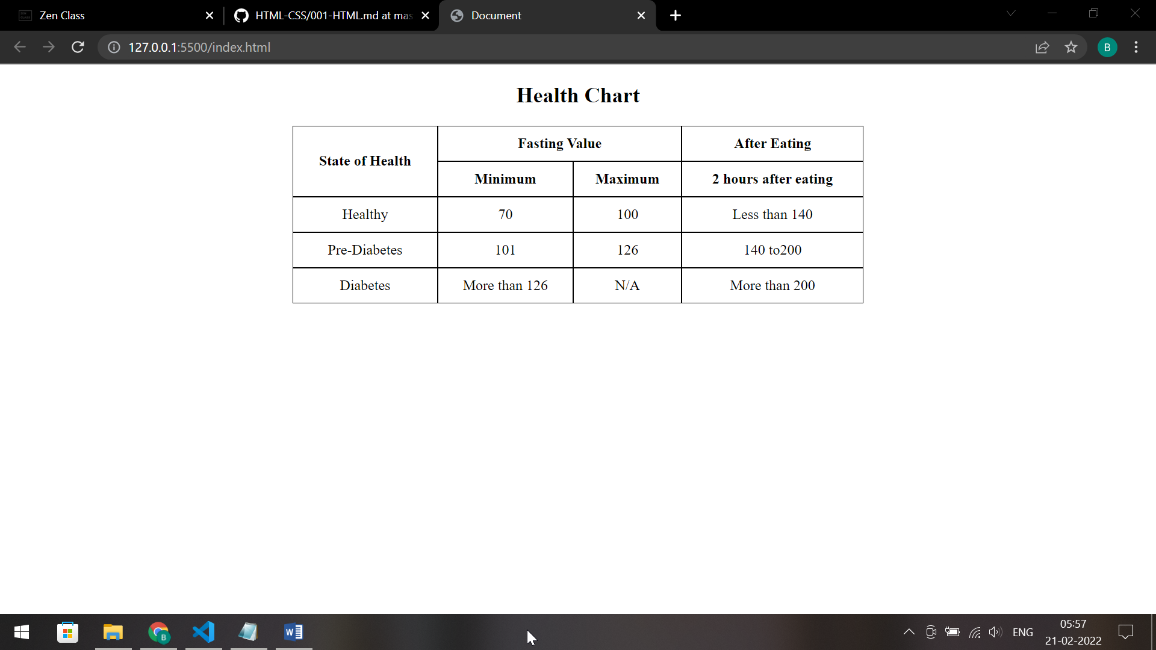

9. Write HTML input tags snippet to show default values for all Form elements.
Code:

10. In your, HTML page add the below line and Highlight it without using any CSS.
"HTML & CSS is awesome"
Code:
<!DOCTYPE html>
<html lang="en">
<head>
<meta charset="UTF-8" />
<meta http-equiv="X-UA-Compatible" content="IE=edge" />
<meta name="viewport" content="width=device-width, initial-scale=1.0" />
<title>Document</title>
</head>
<body>
<p><mark>HTML & CSS is awesome</mark></p>
</body>
</html>

Output:
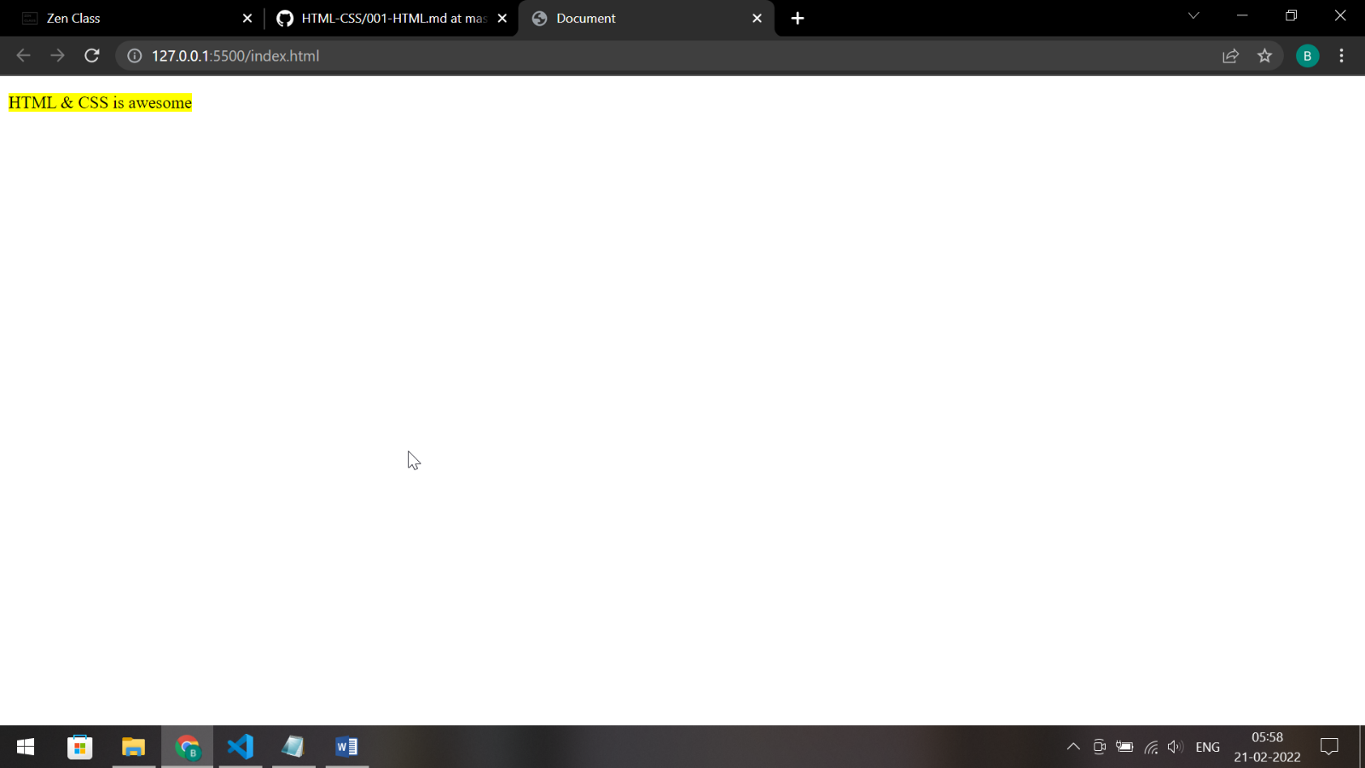
11. Create an HTML page, which should contain all types of input elements.
Code:
<!DOCTYPE html>
<html lang="en">
<head>
<meta charset="UTF-8" />
<meta http-equiv="X-UA-Compatible" content="IE=edge" />
<meta name="viewport" content="width=device-width, initial-scale=1.0" />
<title>Document</title>
</head>
<body>
<label>Button : </label><input type="button" /><br /><br />
<label>Chech Box : </label><input type="checkbox" /><br /><br />
<label>Color : </label><input type="color" /><br /><br />
<label>Date : </label><input type="date" /><br /><br />
<label>Date and Time : </label><input type="datetime" /><br /><br />
<label>Date and Time (Local) : </label><input type="datetime-local" /><br /><br />
<label>Email : </label><input type="email" /><br /><br />
<label>File : </label><input type="file" /><br /><br />
<label>Hidden : </label><input type="hidden" /><br /><br />
<label>Image : </label><input type="image" /><br /><br />
<label>Month : </label><input type="month" /><br /><br />
<label>Number : </label><input type="number" /><br /><br />
<label>Password : </label><input type="password" /><br /><br />
<label>Range : </label><input type="range" /><br /><br />
<label>Reset : </label><input type="reset" /><br /><br />
<label>Search : </label><input type="search" /><br /><br />
<label>Submit : </label><input type="submit" /><br /><br />
<label>Tel : </label><input type="tel" /><br /><br />
<label>Text : </label><input type="text" />
</body>
</html>

Output:
